# Quinte Financial Technologies | FinTech Solutions

**Assignment on**

**CONSUMER FINANCIAL PROTECTION BUREAU, ANTI-MONEY LAUNDERING REGULATION** **& KNOW YOUR CUSTOMER**

**Under Supervision of:**

**Mr. Mohammad Mozammil**

**Submitted On:**

**12th June, 2024**

**Submitted By:**

**Archita Gupta**

Table of Contents

Consumer Financial Protection Bureau (CFPB) 4

Key Functions and Responsibilities: 4

Brief History: 7

Legal Challenges and Disputes: 8

Anti-Money Laundering (AML) Regulation 10

Know Your Client (KYC) 14

# Consumer Financial Protection Bureau (CFPB)

Consumer Financial Protection BureauThe Consumer Financial Protection Bureau (CFPB. is an independent agency of the United States established by the Dodd-Frank Wall Street Reform and Consumer Protection Act in 2010. Its primary mission is to protect consumers in the financial sector by enforcing federal consumer financial laws and promoting fair and transparent practices.

CFPB's jurisdiction includes banks, credit unions, securities firms, payday lenders, mortgage-servicing operations, foreclosure relief services, debt collectors, and other financial companies operating in the United States. Since its founding, the CFPB has used technology tools to monitor how financial entities used social media and algorithms to target consumers.

Once a financial institution acquires $10 billion in assets, it falls under the guidance, rules, and regulations under the CFPB. The bank will then be known as a CFPB regulated bank.

## Key Functions and Responsibilities:

1. **Regulation:**

* **Rulemaking Activities:** The CFPB develops and implements regulations to enforce consumer protection laws. This includes issuing new rules, amending existing ones, and providing guidance to financial institutions. In 2021, the CFPB issued 15 significant rules and amendments, addressing issues such as mortgage servicing, debt collection practices, and small business lending transparency.
* **Key Regulations:**
  + **Qualified Mortgage (QM) Rule:** Designed to prevent risky lending practices and ensure borrowers have the ability to repay their loans.
  + **Payday Lending Rule:** Regulates payday loans, auto title loans, and certain high-cost installment loans to protect consumers from predatory lending practices.
  + **Fair Debt Collection Practices Act (FDCPA):** Updated rules to prevent abusive debt collection practices and ensure fair treatment of consumers.

1. **Supervision:**

* **Supervisory Authority:** The CFPB supervises large banks, thrifts, and credit unions with assets over $10 billion, as well as nonbank financial entities like mortgage lenders, payday lenders, and private student loan companies. In 2021, the CFPB supervised more than 100 large depository institutions and numerous non-depository institutions. This supervisory scope covers over 80% of the assets in the U.S. banking system.
* **Examination Process:** The CFPB conducts regular examinations of supervised institutions to assess compliance with consumer protection laws. These examinations involve reviewing policies, procedures, and practices, as well as conducting on-site visits and interviews. In 2021, the CFPB completed over 200 examinations and targeted reviews, identifying significant violations and risks to consumers.
* **Enforcement Actions from Supervision:** When examinations reveal violations, the CFPB can take enforcement actions, which may include penalties, restitution, or required changes to business practices. In 2021, enforcement actions resulting from supervisory activities led to over $1 billion in penalties and consumer restitution**.**
* **Specific Supervision Programs:**
  + - * **Mortgage Servicing Supervision:** Focuses on ensuring that mortgage servicers follow laws related to loan modifications, foreclosures, and error resolution. In 2021, the CFPB identified widespread issues in mortgage servicing, leading to enforcement actions against multiple servicers and resulting in significant consumer relief.
      * **Fair Lending Supervision**: Ensures compliance with laws such as the Equal Credit Opportunity Act (ECOA) to prevent discriminatory lending practices. The CFPB’s fair lending supervision in 2021 led to enforcement actions addressing discrimination in auto lending and mortgage lending, resulting in millions of dollars in remediation for affected consumers.
      * **Student Loan Servicing Supervision:** Examines student loan servicers to ensure compliance with federal laws and fair treatment of borrowers. In 2021, the CFPB’s oversight of student loan servicers led to significant findings of non-compliance, resulting in corrective actions and restitution for borrowers.

1. **Consumer Education**: Provides consumers with clear, accurate information to help them make informed financial decisions.
   * **Tools**: Offers resources and tools, such as financial guides, calculators, and educational programs, to enhance financial literacy.
   * The CFPB's educational resources reached over 10 million consumers in 2021 through various programs and online tools.
2. **Complaint Handling**:
   * **Consumer Complaints**: Receives and processes consumer complaints about financial products and services. It works with companies to respond to and resolve these complaints.
   * **Transparency**: Publishes complaint data to provide insights into common issues and trends in the financial marketplace.
   * In 2021, the CFPB handled over 400,000 consumer complaints, with the most common issues relating to credit or consumer reporting, debt collection, and credit cards.

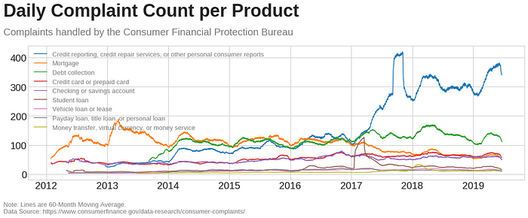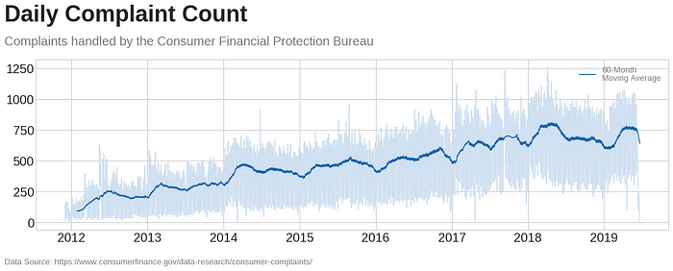

1. **Research and Monitoring**:
   * **Market Analysis**: Conducts research on consumer financial markets, behaviors, and trends to identify emerging risks and opportunities.
   * **Data Collection**: Collects and analyzes data to inform policy decisions and regulatory actions.
   * The CFPB published over 30 research reports in 2021, covering topics such as payday lending, consumer credit trends, and mortgage market activity.
2. **Enforcement Actions**:
   * **Legal Actions**: Takes legal actions against companies and individuals that violate consumer financial protection laws, seeking remedies such as fines, penalties, and consumer restitution.
   * **Settlements**: Reaches settlements with financial institutions to address violations and provide relief to affected consumers.
   * In 2021, the CFPB secured over $2 billion in consumer relief through enforcement actions and settlements.

## ****Brief History:****

The Consumer Financial Protection Bureau (CFPB) was established by the Dodd-Frank Wall Street Reform and Consumer Protection Act in 2010, in response to the 2008 financial crisis. The crisis exposed significant weaknesses in consumer protection and financial regulation, as predatory lending and insufficient oversight contributed to widespread economic instability.

Elizabeth Warren, then a Harvard Law School professor, was a driving force behind the CFPB's creation and served as a special advisor to set up the agency. Richard Cordray was the CFPB's first director, confirmed by the Senate in 2013.

## Legal Challenges and Disputes:

**2017**:

* **Leadership Dispute**: After Director Richard Cordray resigned in November 2017, a legal battle ensued over his successor. Cordray appointed Leandra English as acting director, while President Trump appointed Mick Mulvaney.
* **Court Ruling**: The U.S. District Court for the District of Columbia ruled in favor of the Trump administration, allowing Mulvaney to serve as acting director. This decision was based on the Federal Vacancies Reform Act, which the court found applicable in this case.

**2019**:

* **Constitutionality Challenge**: The CFPB faced a significant legal challenge questioning the constitutionality of its structure, specifically the single-director setup who could only be removed by the President for cause.
* **Court Ruling**: In October 2019, the U.S. Court of Appeals for the Ninth Circuit upheld the CFPB's structure. However, the case was set for review by the Supreme Court, reflecting ongoing controversy and division over the bureau’s design and powers.

**2022**:

* **Supreme Court Decision**: In June 2020, the Supreme Court ruled in **Seila Law LLC v. CFPB** that the CFPB's structure, with a single director who could only be removed by the President for cause, was unconstitutional. The decision allowed the President to remove the CFPB director at will, thereby increasing executive control over the agency.
* **Continued Legal Scrutiny**: Despite the Supreme Court decision, the CFPB continued to face challenges regarding its actions and regulations. In 2022, legal disputes focused on the agency's rulemaking authority and its interpretation of specific consumer protection laws.

**2023**:

* **Funding Structure Challenge**: A major legal challenge in 2023 questioned the CFPB’s funding mechanism. The CFPB is funded through the Federal Reserve, not through Congressional appropriations, which some argue violates the Appropriations Clause of the U.S. Constitution.
* **Court Ruling**: In October 2022, the U.S. Court of Appeals for the Fifth Circuit ruled that the CFPB's funding structure was unconstitutional, which could potentially impact the bureau’s operations and authority. The case is likely to be reviewed by the Supreme Court, indicating ongoing legal battles and uncertainty about the CFPB’s future
* **Enforcement Actions**: Throughout 2023, the CFPB continued its enforcement activities, leading to significant settlements and penalties against various financial institutions. These actions demonstrate the agency’s ongoing role in consumer protection despite legal uncertainties.

# Anti-Money Laundering (AML) Regulation

Anti-Money Laundering (AML) regulations are designed to prevent, detect, and report money laundering activities and other financial crimes. These regulations are critical for maintaining the integrity of the financial system and ensuring that financial institutions do not become conduits for illicit activities.

Financial institutions invest heavily in AML compliance, with global spending on AML compliance estimated to reach $8 billion annually

**Key Components**:

1. **Bank Secrecy Act (BSA)**:
   * **Established**: 1970.
   * **Purpose**: Requires financial institutions to keep records of and report certain financial transactions to the government.
   * **Reporting Requirements**:
     + **Currency Transaction Reports (CTR)**: Filed for transactions exceeding $10,000.
     + **Suspicious Activity Reports (SAR)**: Filed when a transaction is suspected to involve illegal activity.

Financial institutions filed over 2 million SARs with FinCEN in 2021, indicating proactive efforts to detect and report suspicious activities.

1. **USA PATRIOT Act**:
   * **Established**: 2001, in response to the 9/11 terrorist attacks.
   * **Purpose**: Strengthens AML measures and enhances law enforcement's ability to detect and prevent money laundering and terrorism financing.
   * **Key Provisions**:
     + **Know Your Customer (KYC)**: Requires financial institutions to verify the identity of their customers.
     + **Enhanced Due Diligence (EDD)**: Additional scrutiny for high-risk customers and transactions.
     + **Information Sharing**: Facilitates information sharing between financial institutions and government agencies.
2. **Customer Due Diligence (CDD) Rule**:
   * **Implemented by**: Financial Crimes Enforcement Network (FinCEN).
   * **Effective Date**: May 11, 2018.
   * **Purpose**: Requires financial institutions to identify and verify the identity of beneficial owners of legal entity customers.
3. **Anti-Money Laundering Act of 2020**:
   * **Established**: As part of the National Defense Authorization Act for Fiscal Year 2021.
   * **Purpose**: Modernizes and strengthens AML laws, expands FinCEN’s authority, and enhances communication and coordination among financial institutions and regulatory agencies.
   * **Key Features**:
     + **Beneficial Ownership Registry**: Requires reporting of beneficial ownership information to FinCEN.
     + **Whistleblower Provisions**: Offers incentives and protections for whistleblowers reporting AML violations.

**Regulatory Agencies**:

1. **Financial Crimes Enforcement Network (FinCEN)**:
   * **Role**: Administers the BSA and enforces compliance with AML regulations.
   * **Activities**: Issues regulations, collects and analyzes financial transaction data, and coordinates with other regulatory and law enforcement agencies.

In 2020, U.S. regulators imposed over $1.4 billion in penalties for AML violations, reflecting the rigorous enforcement of AML regulations

1. **Office of the Comptroller of the Currency (OCC)**:
   * **Role**: Supervises national banks and federal savings associations, ensuring compliance with AML laws.
   * **Activities**: Conducts examinations, enforces regulations, and issues guidance to banks.
2. **Federal Reserve**:
   * **Role**: Supervises bank holding companies, state-chartered banks, and other financial institutions.
   * **Activities**: Conducts AML examinations and enforces compliance with AML regulations.
3. **Federal Deposit Insurance Corporation (FDIC)**:
   * **Role**: Supervises state-chartered banks that are not members of the Federal Reserve System.
   * **Activities**: Ensures compliance with AML laws through examinations and enforcement actions.

**How AML Was Established**:

1. **Bank Secrecy Act (BSA)**: The foundation of AML regulation in the U.S. is the Bank Secrecy Act (BSA), enacted in 1970. The BSA was initially aimed at addressing concerns about money laundering associated with organized crime and drug trafficking.
2. **Expanding Threats**: Over time, the scope of AML regulation expanded to address emerging threats such as terrorism financing, corruption, and cybercrime. Globalization and advances in technology also contributed to the need for more sophisticated AML measures.
3. **Legislative Enhancements**: Subsequent legislative efforts, such as the USA PATRIOT Act of 2001, further strengthened AML regulations in response to the 9/11 terrorist attacks. The USA PATRIOT Act introduced new provisions, including enhanced customer due diligence (CDD), expanded reporting requirements, and increased information sharing among financial institutions and law enforcement agencies.

**Why AML Was Established**:

1. **Preventing Crime and Terrorism Financing**:
   * A primary objective of AML regulations is to prevent criminals and terrorists from using the financial system to launder illicit proceeds or finance illegal activities.
   * By detecting and disrupting money laundering activities, AML measures help prevent crime and protect national security.
2. **Preserving Financial Integrity**:
   * Money laundering undermines the integrity of the financial system by allowing illicit funds to enter legitimate channels undetected.
   * AML regulations aim to safeguard the integrity of financial institutions and markets, maintaining public trust and confidence in the financial system.
3. **Global Efforts and Obligations**:
   * The U.S. participates in international efforts to combat money laundering and terrorism financing, such as the Financial Action Task Force (FATF).
   * AML regulations help fulfill international obligations and promote cooperation with other jurisdictions in combating financial crimes.
4. **Enhancing Transparency and Accountability**:
   * AML regulations promote transparency by requiring financial institutions to identify and verify the identities of their customers and report suspicious activities.
   * By enhancing transparency and accountability, AML measures deter criminals from exploiting the financial system for illicit purposes.

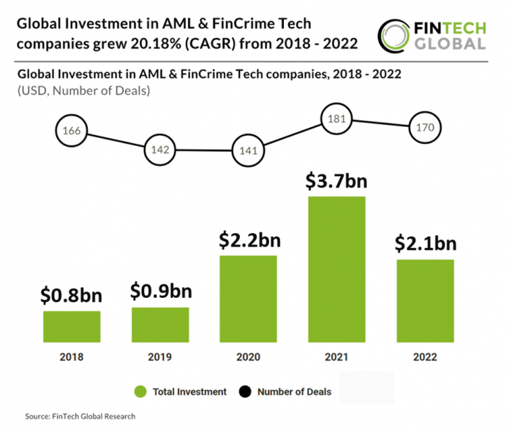

* The United States is home to an annual fraud volume exceeding **$300 billion.**
* Every year; thieves across the globe launder an estimated annual total of between **$800 million and $2 trillion through fraudulent practices.**
* **Global banks were penalized $10.4 billion for money-laundering** offenses in 2022 alone.

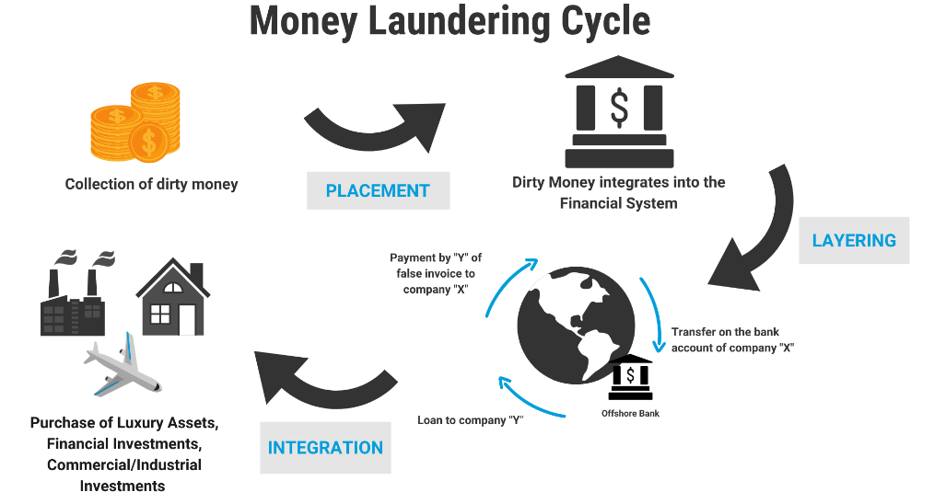

# Know Your Client (KYC)

Know Your Customer (KYC) regulations are a fundamental component of anti-money laundering (AML) and counter-terrorism financing (CTF) efforts.

KYC regulations require financial institutions to verify the identity of their customers, assess their risk profiles, and understand the nature of their financial activities. By obtaining comprehensive information about customers, financial institutions can mitigate the risk of facilitating money laundering, terrorist financing, and other illicit activities.

As financial fraudsters enhanced their techniques, Congress determined at various points in time that additional legislation would be necessary. This resulted in new acts, including:

* ***The****Money Laundering Control Act of 1986*, which made money laundering a federal offense.
* *The Annunzio-Wylie Anti-Money Laundering Act of 1992*, which enhanced penalties for financial institutions that were found guilty of money laundering.
* *The Money Laundering and Financial Crimes Strategy Act of 1998*, which amended federal law to require the creation and execution of a nationwide money laundering and related financial crimes strategy.
* *The USA PATRIOT Act of 2001*, which responded to the 9/11 terrorist attacks, implemented new measures to protect against terrorism and money laundering, and helped kickstart KYC requirements like the Customer Identification Program (CIP) and Customer Due Diligence (CDD).
* *The Anti-Money Laundering Act (AMLA) of 2020*, which broadened authorities on financial crime to keep up with globalization and advancing technology.

**Key Components**:

* **Customer Identification**: Financial institutions must collect specific information from customers, including their name, address, date of birth, and identification documents such as passports or driver's licenses.
* **Risk Assessment**: Institutions are required to assess the risk associated with each customer based on factors such as their occupation, source of funds, and transaction history.
* **Ongoing Monitoring**: KYC regulations mandate continuous monitoring of customer transactions and activities to detect any suspicious behavior or patterns.

**Regulatory Framework:**

* **Bank Secrecy Act (BSA)**: Enacted in 1970, the BSA requires financial institutions to establish and maintain effective KYC programs to prevent money laundering and terrorist financing.
* 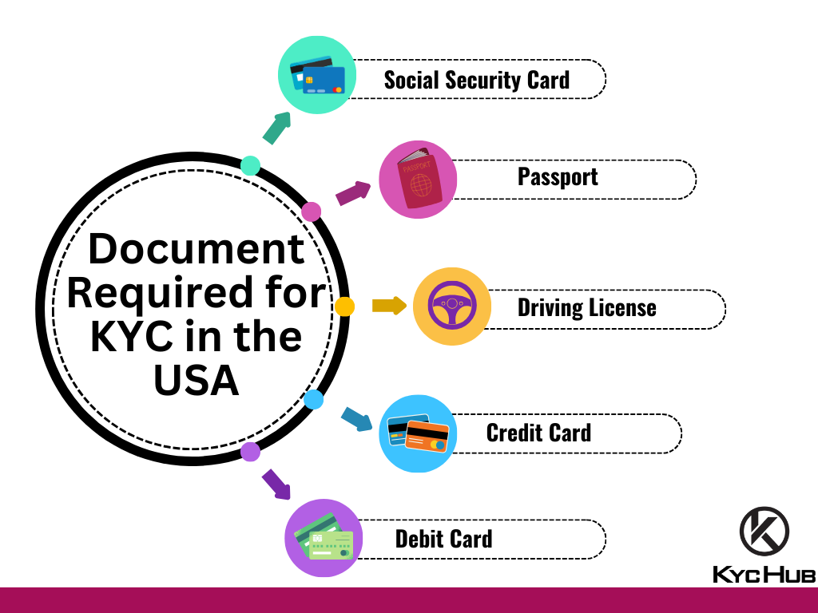**USA PATRIOT Act**: Passed in 2001, the USA PATRIOT Act expanded KYC requirements and introduced enhanced due diligence (EDD) measures for high-risk customers.

With the rise in online transactions, businesses face a high risk of cybersecurity threats. To mitigate these risks, businesses require advanced KYC and AML solutions. These solutions often encompass six distinct ID verification services, including facial verification, document verification, address verification, 2-factor authentication, consent verification, and AML screening.

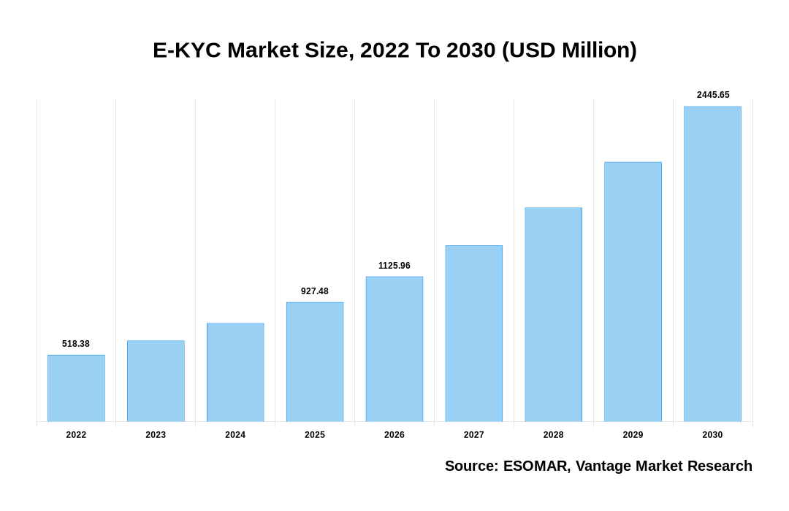The market size is expected to grow steadily over the years, starting at $518.38 million in 2022 and reaching $2445.65 million by 2030. This upward trend suggests an increasing adoption and demand for E-KYC solutions, which are used by financial institutions and other businesses to verify the identities of their customers remotely and comply with regulatory requirements.